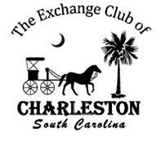
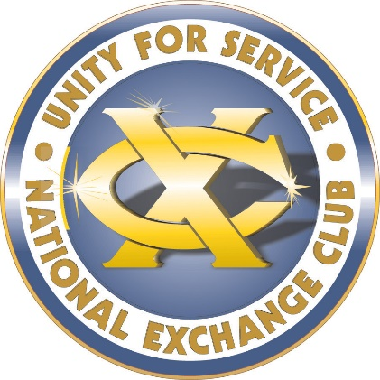
FOR IMMEDIATE RELEASE
Exchange Club of Charleston Recognizes 78 Tri-County Nonprofits

Location / Date: The Exchange Club of Charleston will hold its annual Community Service Awards Ceremony on Thursday, October 24 from 11:30 AM to 1PM at the Coastal Carolina Fairgrounds, 9850 US-78, Ladson, SC 29456.

During Thursday’s ceremony, Exchange Club of Charleston President Tony Guiliani will recognize 78 Tri-County nonprofits that received grants totaling $209,719 to help improve the quality of life for the aged, hungry, handicapped, unemployed, sick, homeless and children in Berkeley, Charleston and Dorchester Counties. President Tony Guiliani states, “The motto of the Exchange Club is Unity for Service. We are so pleased that our members’ volunteer at the Coastal Carolina Fair which enables us to support these wonderful organizations that directly impact the lives of those in need in our local community. The funds will be utilized by the charities to provide direct services to meet the basic needs of food, housing, clothing, education and health.”
The ceremony will be attended by Exchange Club of Charleston members and spouses/dates, chairpersons and directors of nonprofits, Coastal Carolina Fair officers and staff, business partners, Fair sponsors and TV, radio and print media that support and promote the Coastal Carolina Fair. Part of the ceremony is in recognition of their contributions to the Club and Fair to help make a difference in our community. For example,192 Exchange Club of Charleston members worked a total of 14,135 hours at the 2023 Coastal Carolina Fair to make our communities a better place to live, learn and work.
Under the direction of Fair President Donnie Pitts, the 2023 Coastal Carolina Fair was a success and is the primary source of funds that The Exchange Club of Charleston uses to support local charities. In addition to nonprofit grants awarded at the ceremony, Fair funds are distributed by the Club throughout the year for such things as scholarships for local high school and college students, rewarding outstanding service by our public safety and military men and women and honor our many unsung community heroes. The total community impact in 2024 is $504,212.
We are also pleased to announce that The Exchange Club of Charleston has raised $30,000 additional dollars to fund a clean water initiative through local charity, Water Mission https://watermission.org/. This system will stay in the US and be used with immediate affect with the Hurricane Helene disaster.
Contact: J. Wallace, Co-Chairman Media Relations 843.259.1660 Jay@ManagementBlueprints.com

